**Requirement Gathering and Analysis Phase**

**Data Flow Diagram & User Stories**

|  |  |
| --- | --- |
| Date | 3-07-2024 |
| Team ID | SWTID1719933594 |
| Project Name | ShopEZ |
| Maximum Marks | 4 |

**Data Flow Diagrams:**

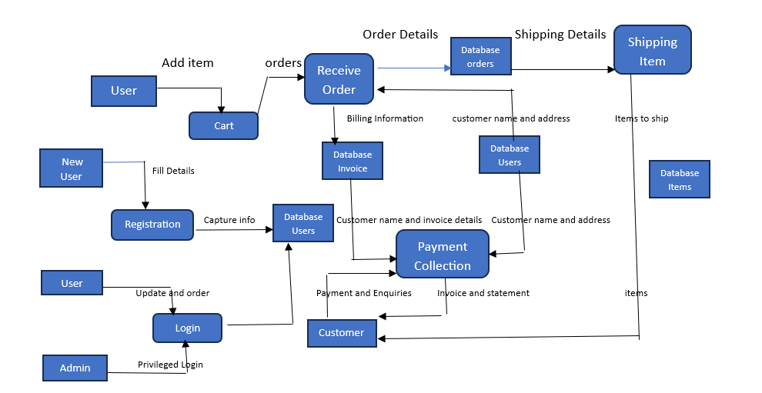

**User Stories**

Use the below template to list all the user stories for the product.

| **User Type** | **Functional Requirement (Epic)** | **User Story Number** | **User Story / Task** | **Acceptance criteria** | **Priority** | **Release** |
| --- | --- | --- | --- | --- | --- | --- |
| Customer (Mobile / Web user) | Registration | USN-1 | As a user, I can register for the application by entering my email, password, and confirming my password. | I can access my account/dashboard | High | Sprint-1 |
|  |  | USN-2 | As a user, I will receive confirmation email once I have registered for the application | I can receive a confirmation email & click confirm | High | Sprint-1 |
|  |  | USN-3 | As a user, I can register for the application through Facebook, Gmail | I can register & access the dashboard with Facebook and Gmail Login | Low | Sprint-2 |
|  | Login | USN-4 | As a user, I can log into the application by entering my email & password | I can access my dashboard | High | Sprint-1 |
|  | Dashboard | USN-5 | As a user, I can view my personal dashboard with my account information and recent orders. | I can see my profile info and recent order history | High | Sprint-2 |
|  | Browse Products | USN-6 | As a user, I can browse products by category and search for specific products | I can see product listings and search results | High | Sprint 2 |
|  | Product Details | USN-7 | As a user, I can view detailed information about a product, including images, descriptions, and reviews. | I can see product details and customer reviews | High | Sprint 2 |
|  | Add to cart | USN-8 | As a user, I can add products to my shopping cart. | I can see selected products in my cart with the correct quantities | High | Sprint 2 |
|  | Checkout | USN-9 | As a user, I can proceed to checkout and complete my purchase using various payment methods. | I can complete my purchase and receive a confirmation of the order | High | Sprint 2 |
| Customer Care Executive | Customer Support | USN-10 | As a customer care executive, I can view and manage customer inquiries and support tickets | I can see, respond to, and close support tickets | High | Sprint 3 |
|  | Order Management | USN-11 | As a customer care executive, I can track and manage customer orders and shipment status. | I can view and update the status of customer orders. | High | Sprint 3 |
| Administrator | User Management | USN-12 | As an administrator, I can manage user accounts, including creating, updating, and deleting accounts. | I can add, update, or remove user accounts as needed | High | Sprint 4 |
|  | Product Management | USN-13 | As an administrator, I can add, update, and remove products from the catalogue. | I can manage the product listings in the catalogue | **High** | **Sprint 4** |
|  | Order Management | USN-14 | As an administrator, I can view and manage all customer orders and their statuses. | can oversee all orders and update their statuses as necessary | High | Sprint 4 |
|  | Analytics | USN-15 | As an administrator, I can view analytics and reports on sales, user activity, and other key metrics. | I can generate and view detailed reports on various aspects of the platform's performance | Medium | Sprint-4 |
|  | Content Management | USN-16 | As an administrator, I can manage the content on the website, including banners, promotions, and other marketing materials. | I can update and manage promotional content and marketing materials | Medium | Sprint 4 |